URL: https://adityabirlahospital.com/blogs/diet-and-pcod

Meta Title: Diet and PCOD: How Nutrition Can Influence Symptoms and Management

Meta Description: Understand how the right diet can help manage PCOD symptoms. Explore nutrition tips, hormone-friendly foods, and lifestyle changes for better health.

H1: Diet and PCOD: How Nutrition Can Influence Symptoms and Management
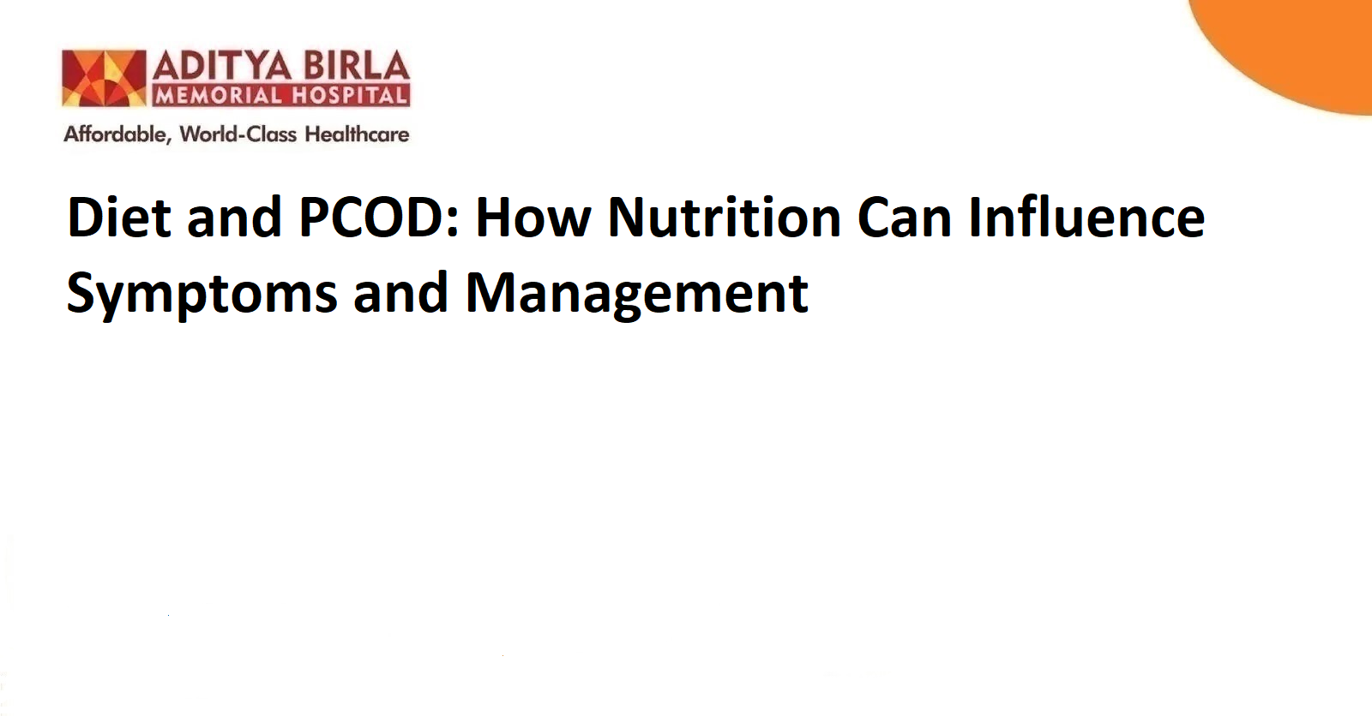
Polycystic Ovarian Disease, often referred to as PCOD, is now one of the most discussed reproductive health issues in young women. It affects both physical wellbeing and hormonal balance. For many, the first signs may begin in adolescence and progress with time if not addressed properly.

Understanding the role of a healthy lifestyle is important, but the influence of diet on PCOD is often underestimated. Every small dietary choice has the potential to either aggravate or ease the condition. This blog offers practical guidance by focusing on how a tailored PCOD diet may support symptom control and long-term wellness.

What Is PCOD and the Factors Contributing to Its Development?
PCOD is a condition in which the ovaries begin producing immature or partially mature eggs in excess. These eggs eventually turn into cysts that may trigger further hormonal imbalance. The body starts experiencing fluctuations in insulin and androgen levels [especially, when ovulation is irregular or does not happen regularly]. This hormonal disruption is what leads to visible signs like weight gain, acne, irregular periods and difficulty in conceiving.

One of the most common factors linked to PCOD is insulin resistance. When your body fails to use insulin efficiently, it results in higher sugar levels, which eventually prompts the ovaries to produce more male hormones. Apart from insulin-related triggers, lifestyle stress, irregular sleep cycles, poor eating habits and lack of exercise may also contribute to the condition. Early diagnosis along with the right PCOD problem treatment diet may help reduce the severity and restore hormonal rhythm.

How Does Diet Influence PCOD?
The impact of diet in PCOD is not restricted to calorie intake or weight gain alone. It also affects hormone production, sugar metabolism, gut health and even mood regulation. Women with PCOD often report feeling lethargic, bloated or emotionally low during flare-ups. The symptoms may worsen when an individual consumer meals that are high in processed sugar, saturated fats or refined carbohydrates.

Choosing the right diet for PCOD patients helps regulate insulin levels [while also reducing inflammation]. Balanced nutrition stimulates better menstrual health and helps manage unwanted hair growth or skin issues that are often linked to hormonal irregularity. A good diet plan for PCOD should focus more on moderation, timing and making smarter food swaps.

Which Diet Helps Better Manage PCOD?
There is no one-size-fits-all PCOD diet chart. However, certain dietary patterns have shown benefits when followed consistently over time. The goal is to improve insulin sensitivity, reduce inflammation and support hormonal balance.

Low Glycaemic Index Foods
Choosing foods with a low glycaemic index, such as oats, brown rice or whole grain bread, helps maintain steady blood sugar levels. These options also keep energy levels more stable throughout the day.

Fibre-Rich Vegetables and Fruits
Including fibre from leafy greens, berries, apples or legumes helps digestion and reduces the sudden spike in sugar after meals. Fibre is also essential for clearing excess hormones from the body.

Lean Proteins and Healthy Fats
Incorporating eggs, fish, tofu, nuts or seeds supports better satiety. These options help reduce cravings and may promote hormonal regulation.

Fermented and Gut-Friendly Foods
Including curd, yoghurt or other probiotic foods may help restore digestive balance, which indirectly supports hormonal harmony. Gut health plays an important role in managing PCOD symptoms over time.

Mindful Eating Patterns
Eating smaller, regular meals instead of skipping or binge eating helps stabilise both insulin and hunger hormones. This approach is part of an effective diet plan for PCOD.

By following a balanced approach, women can experience better control over their symptoms and overall wellbeing.

Food Options That You Must Avoid To Effectively Manage PCOD
While no food needs to be feared completely, certain choices may worsen hormonal imbalance when consumed frequently or in large quantities. These items should ideally be limited if not avoided altogether in a diet to cure PCOD.

Refined Carbohydrates
Foods made using maida, white bread or polished rice may spike blood sugar levels quickly and worsen insulin resistance. Reducing their intake supports hormonal balance.

Sugary Beverages and Packaged Juices
These options add empty calories and may affect blood sugar control. They offer little nutrition and may increase the intensity of PCOD symptoms over time.

Processed and Fried Foods
Chips, fast food, or frozen snacks often contain unhealthy fats. These may increase inflammation and also lead to weight gain, which may complicate PCOD management.

Red Meats in Excess
While protein is essential, consuming red meat regularly may increase saturated fat intake which affects cardiovascular and hormonal health in women with PCOD.

Dairy Products
Some individuals may find that full-fat milk, cream or cheese worsens their acne or bloating. Observing how the body responds may help personalise the diet in PCOD.

Avoiding these foods helps not only in symptom control but also in preventing other complications linked to PCOD such as prediabetes or obesity. Women seeking long-term prevention of PCOD often benefit from a simple and sustainable food plan that suits their routine and cultural background.

Conclusion
PCOD is a complex hormonal condition that affects different aspects of life including fertility, weight, skin and mental health. While the causes are linked to both genetics and lifestyle, food choices play a powerful role in either aggravating or easing the symptoms. A structured PCOD diet supports hormone regulation and improves overall well being.

Whether one is exploring how to reduce PCOD problems or looking for better symptom control, nutrition remains a reliable first step. For detailed guidance, speaking to gynaecologists in Pimpri-Chinchwad or reaching out to an obstetrics and gynaecology hospital in Pimpri-Chinchwad may help design a personalised approach. But change often begins at the dining table.

FAQs

What is the role of nutrition in managing PCOD?
Nutrition helps regulate insulin levels, manage weight and reduce inflammation. A balanced diet supports hormone balance. It also may improve the menstrual cycle and skin health in women with PCOD.

How do you treat PCOD symptoms?
PCOD symptoms are usually managed through lifestyle changes [such as adopting a tailored PCOD diet, regular physical activity, stress control and medical follow-up where required].

What are common PCOD symptoms?
Irregular periods, weight gain, acne, excessive hair growth and difficulty conceiving are some of the common symptoms. Emotional changes such as mood swings or fatigue may also occur in some individuals.

What is the best solution for PCOD?
There is no single solution. A combination of the right diet, physical activity, stress reduction and regular check-ups may help manage symptoms and support ong-term prevention of PCOD.

References:

https://oasisindia.in/blog/pcod-diet-foods-to-eat-and-avoid/

https://apollodiagnostics.in/blogs/diet-and-pcod-how-nutrition-can-influence-symptoms-and-management

